Day 3: API Integration and Data Migration

1. Created a project in Sanity:

A new project was created in the Sanity platform.

2) Created a project named 'Day3' in Sanity

A separate project, titled 'Day3', was created for better organization.

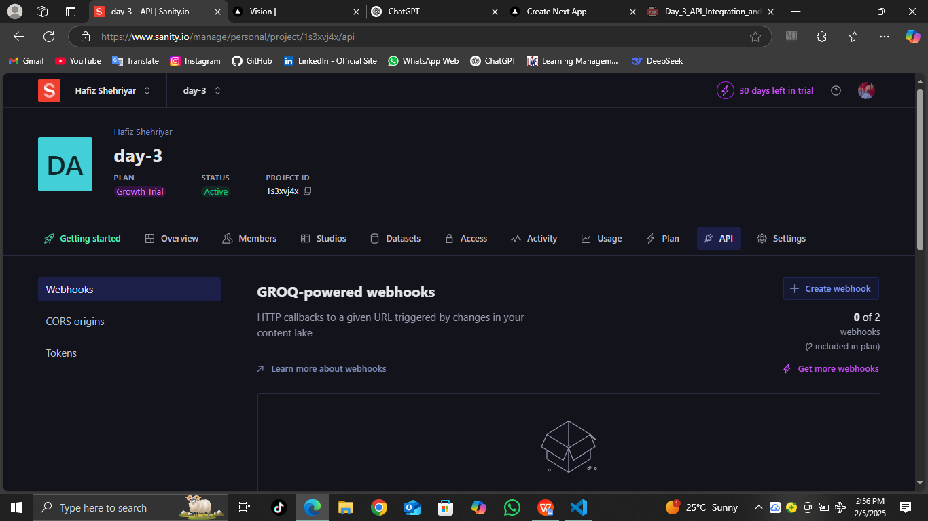

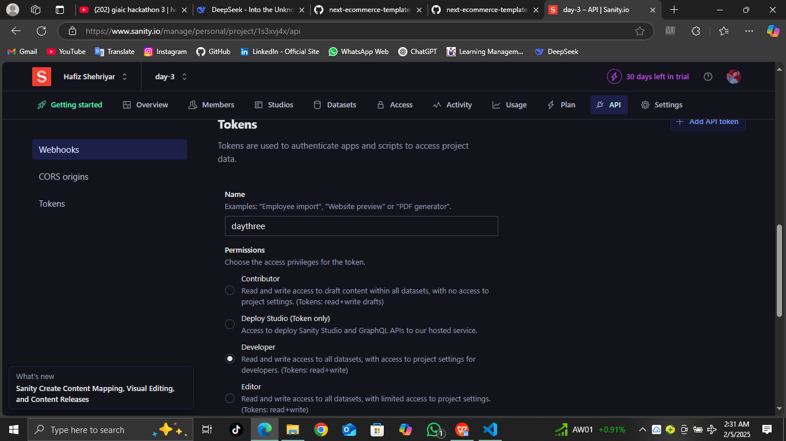

1. Generated API Token and stored it in Developer Options
2. An API token was generated and securely placed in the developer section.

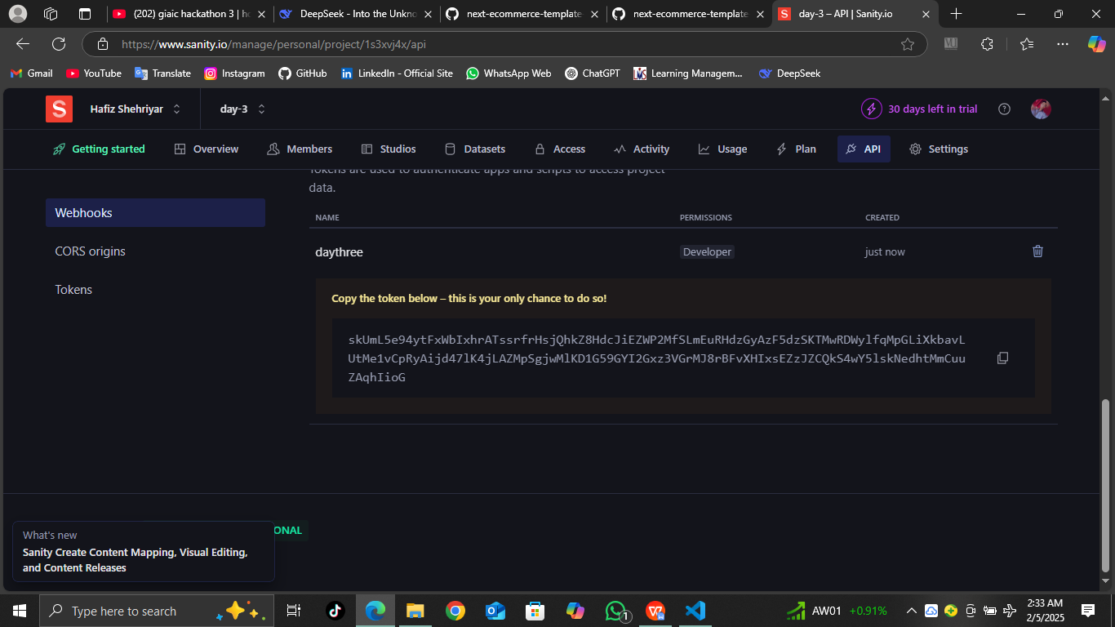

1. Added environment file for all three steps

An environment file was added to manage configurations for all tasks.

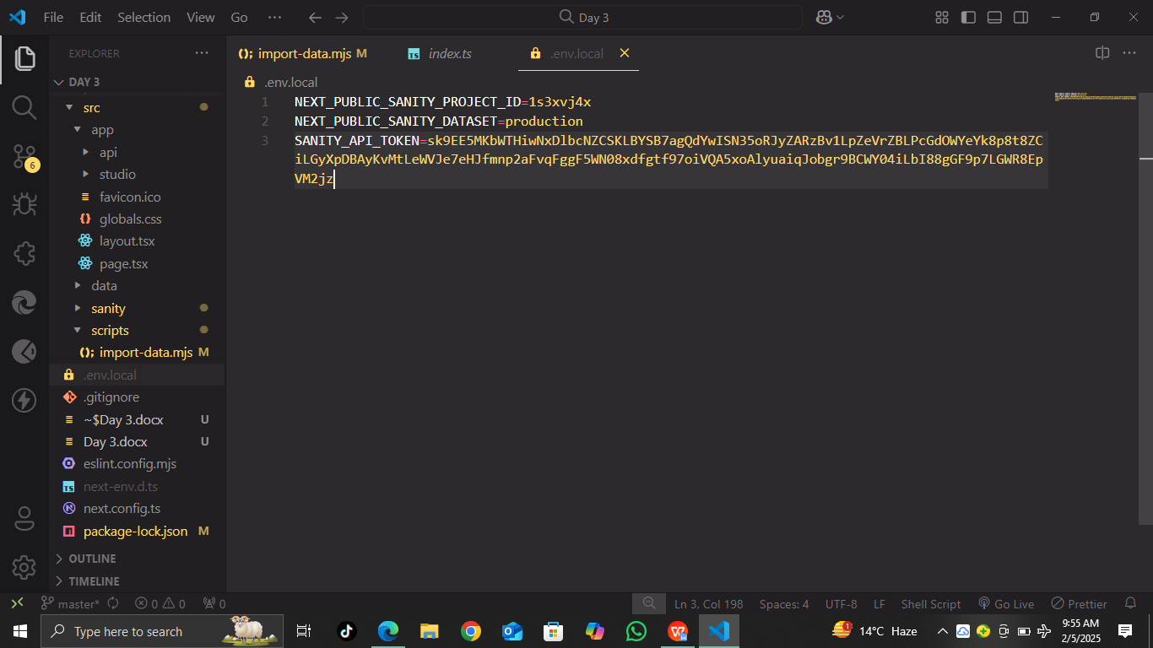

1. Created Product schema file and added schema

A schema file for products was created and the schema structure was added.

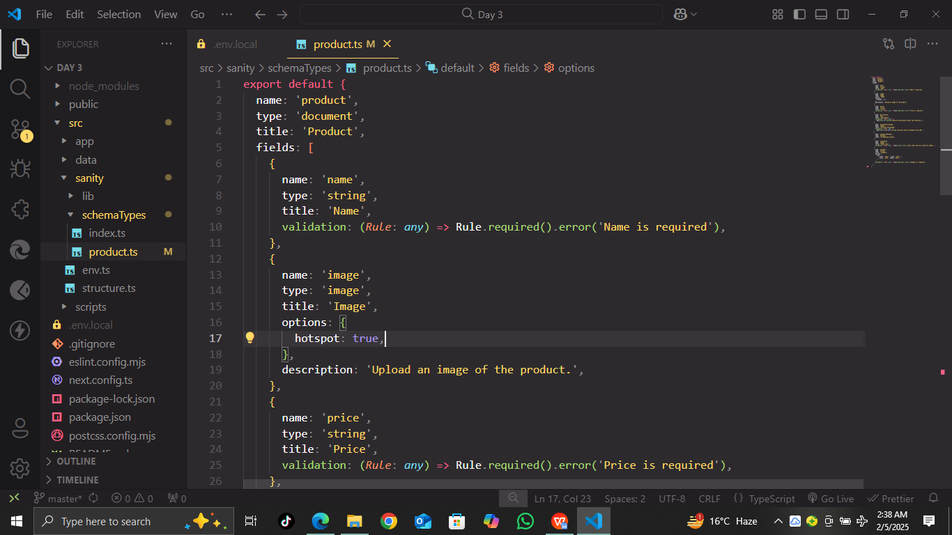

1. Created a scripts folder and added import-data.mjs file

A folder for scripts was created, and an import-data.mjs file was added for data import functionality.

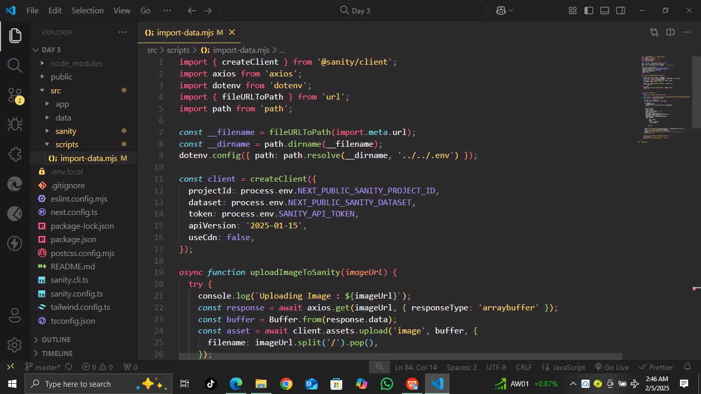

1. Defined type module and added import-data script in package-lock.json

The package-lock.json file was updated to define the type module and include the import-data script.

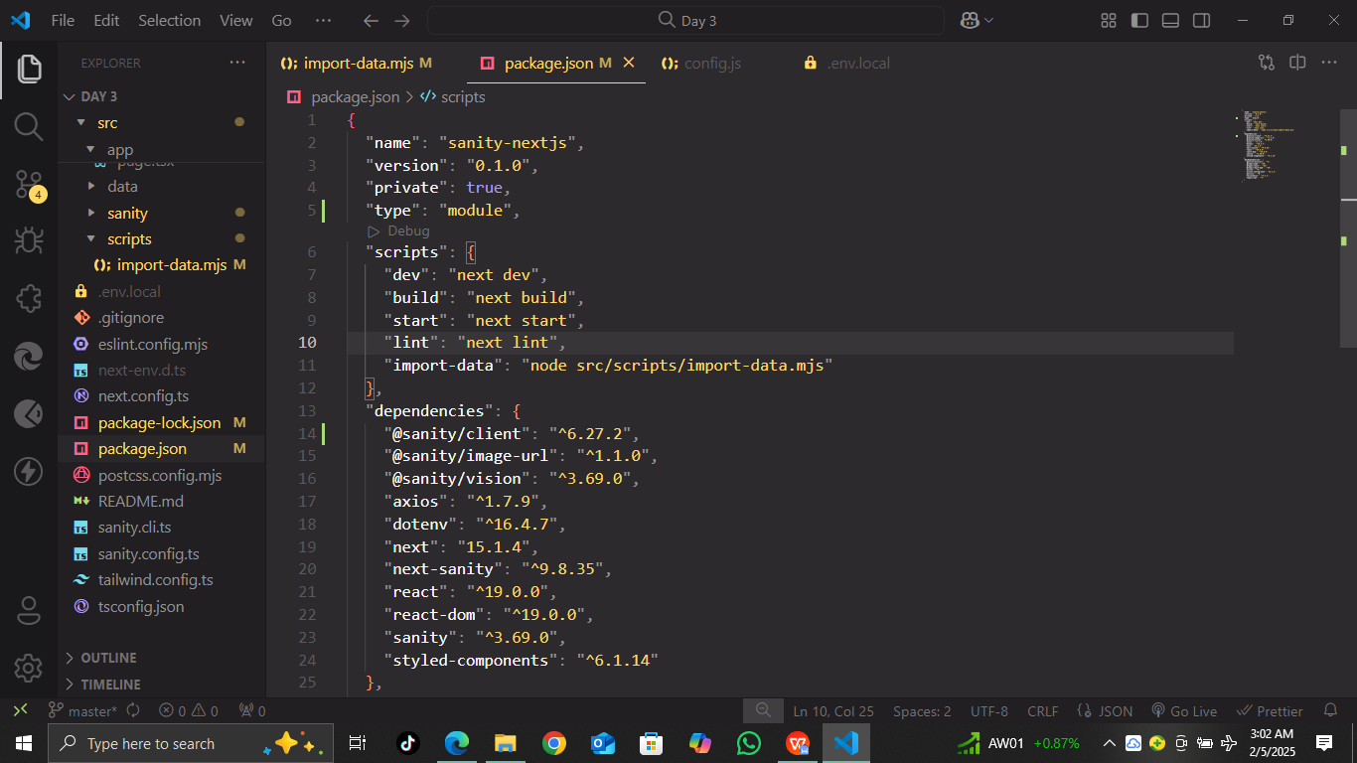

1. Executed the import data command, and all data fetched successfully in terminal

The import data command was executed, and all the data was fetched and displayed in the terminal.

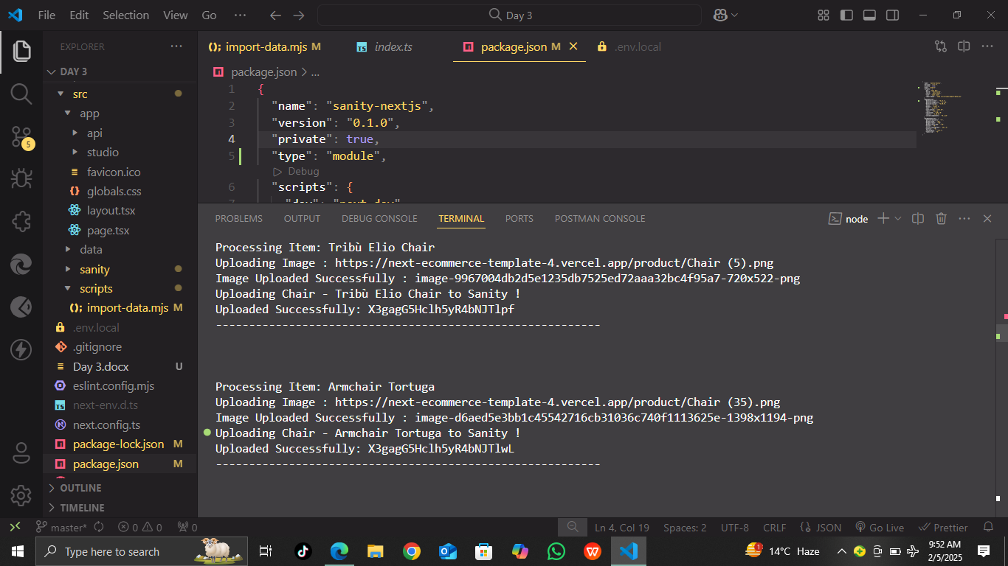

1. Verified collection in Sanity.io, confirming data presence

The data was successfully verified in the collection section of Sanity.io.

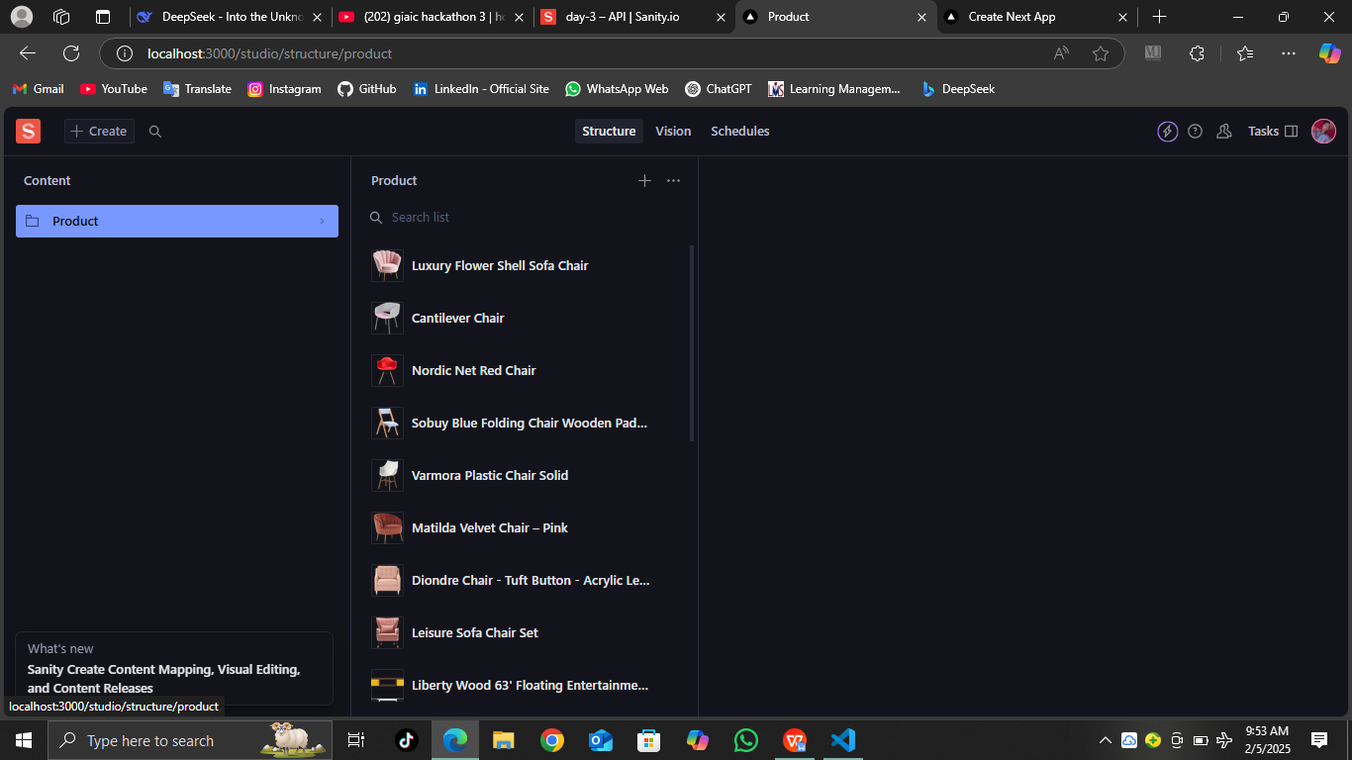

1. Created and executed a query in Sanity’s Vision tool to fetch data

A query was created in Sanity's Vision tool to retrieve the data.

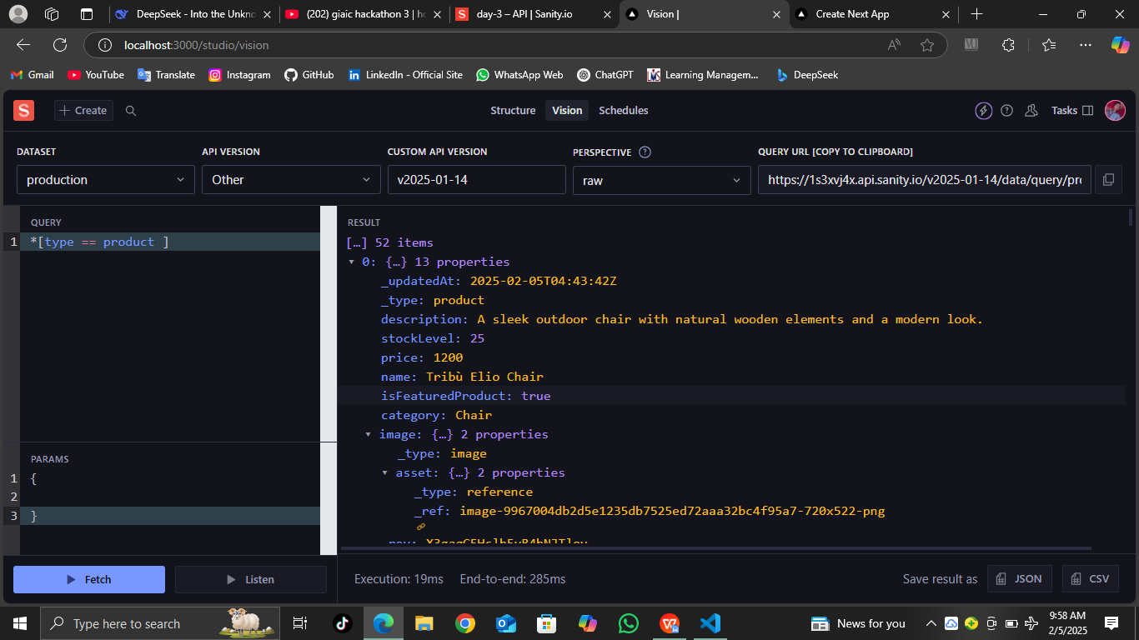

1. Created 'Product' folder and rendered data in the corresponding file

A 'Product' folder was created, and a page to render product data was built.

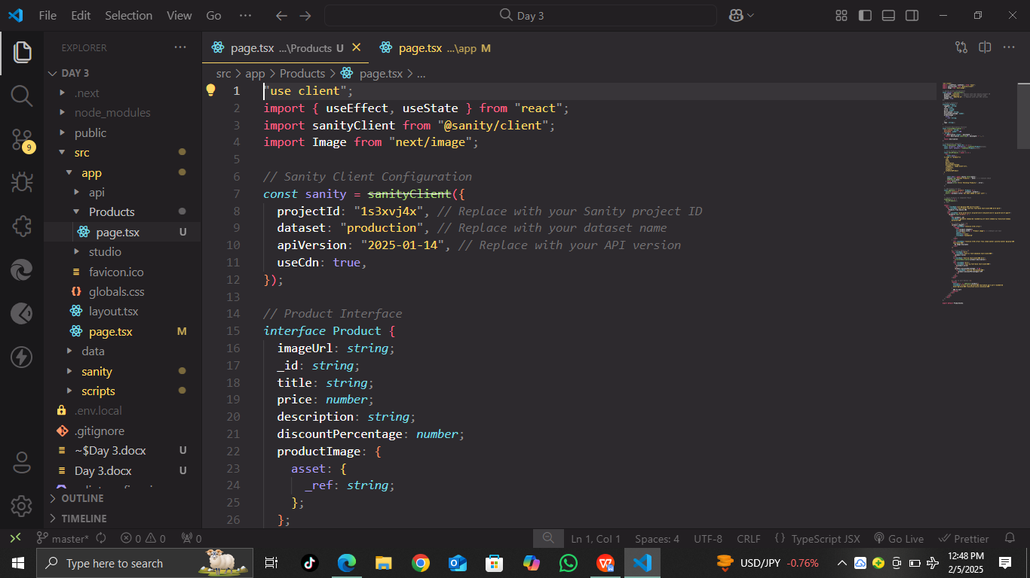

1. Imported and added components to the Home page

The required components were imported and added to the Home page for display.

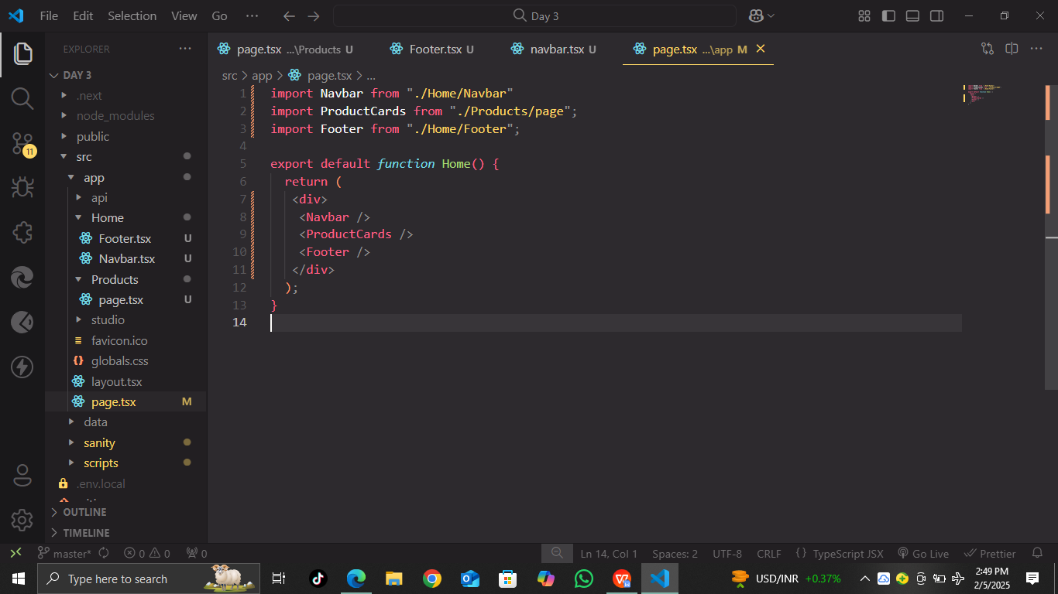

1. Finalized and rendered data on the browser

Finally, the data was rendered successfully on the browser.

